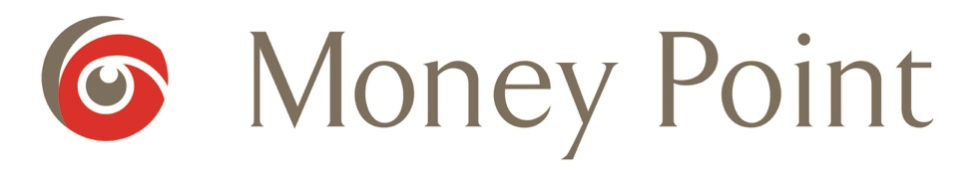

Customer Returns Request Form

Name
Phone
Email
Address
Product
Order Number
Order Date
Delivery Date

Reason for Return (please tick one):

Not as expected
Damaged
Faulty
Did not match website description
Changed my mind
Ordered wrong product
Late delivery
No longer needed

Please provide full details of the issue in the box below.

Email the completed form to support@moneypoint.ie with the original order number, any relevant images and the word 'Return' in the subject line. Wait for an email to confirm that your return request has been accepted. Arrange to have the item(s) sent back to us at 19 Turvey Business Centre, Turvey, Co. Dublin K36 P624.

